**Other Events/Information**

Please remember to bring reading books and journals back to school daily. This is so that we can read with your child in school and change their reading book (on a FRIDAY). Can we also ask that you read with your child at home and write in their reading journal – if they read 3+ times a week their name will be added to a jar, with the chance win a prize every half term.

School closes for the October break on **Thursday 19th** **October** and reopens on **Monday 30th October**

**Writing**

In writing, we will be looking at sentence structure for example; capital letters, full stops, finger spaces and phonics spelling.

We will be focussing on using the storybook Tidy to compose different narrative sentences.

After half term we will complete sound poems based on Bonfire Night.

**RE**

In RE this term we will be learning about key aspects of Christianity and the creation story.

We will introduce the key question – Do Christians think God wants them to look after the world? What do you think about this and why?

**Maths**

In Maths this term we will be focusing on place value within 10 and addition and subtraction within 10.

Small Steps of learning:

• Sort objects/Count objects.

• Count objects from a larger group.

• Represent objects.

• Recognise numbers as words.

• Count on from any number within 10.

• Count one more/one less

• Count backwards within 10 .

• Compare groups by matching.

• Fewer, more, same.

• Less than, greater than, equal to.

• Compare numbers.

• Order objects and numbers.

• The number line.

• Part-whole model.

• Write number sentences.

• Fact families – Addition facts.

• Number bonds to/ within 10.

• Addition: Add together.

• Addition problems.

• Subtraction: Find a part/subtraction on a number line

**Science: Materials**

In this topic, we will enjoy completing lots of experiments.

We will be learning about:

* To identify different materials in our environment. .
* The different uses of everyday materials.
* To sort different everyday materials and their properties.

**EMBRACE**

We are learning about ‘Being me in my world’ This covers how we feel safe, recognising choices and becoming a class team. We will also look at rewards and consequences and discuss how our actions can affect themselves and others.

During the autumn term, we will be also celebrating differences, learning how to not judge by appearances, making assumptions and understanding how to recognise bullying.

**PE**

PE this term is on TUESDAY and FRIDAY

Please send your child to school with the correct PE kit for them to get changed into.

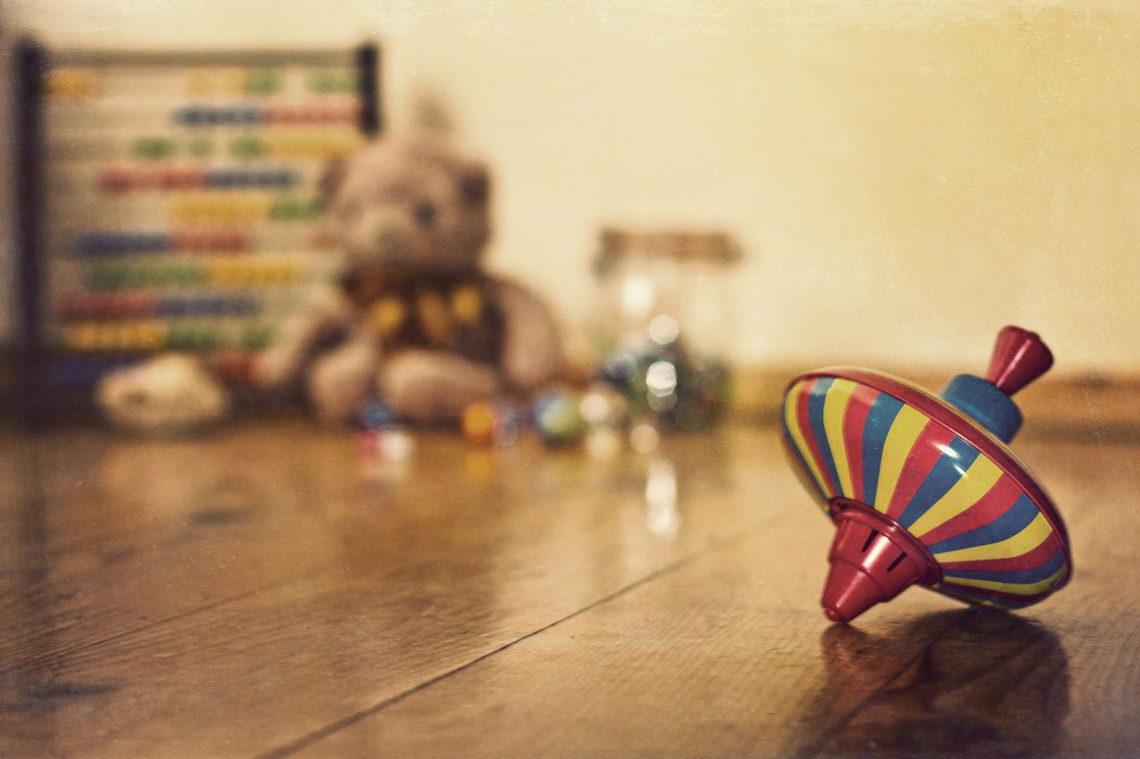

**Topic - History**

This term we will be teaching children about everyday life and families today, including comparisons with childhood in the 1950s, using artefacts and a range of different sources.

We will be focussing on:

* Growing up from babies to elderly.
* Memories.
* Toys from the past. Comparing toys, past and present.

**Autumn Term: Childhood**