School Check List

For School I Need:

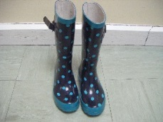 Wellingtons (to remain in school)
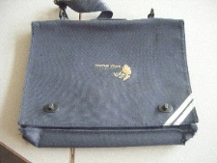 School Book Bag (Labelled with name)
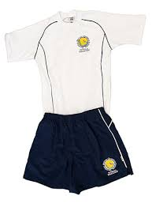 P.E. kit (Labelled with name)
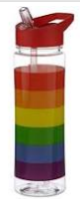

Water bottle (Labelled with name)

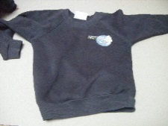 Uniform (Labelled with name)

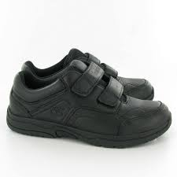 Velcro Shoes (Labelled with name)

