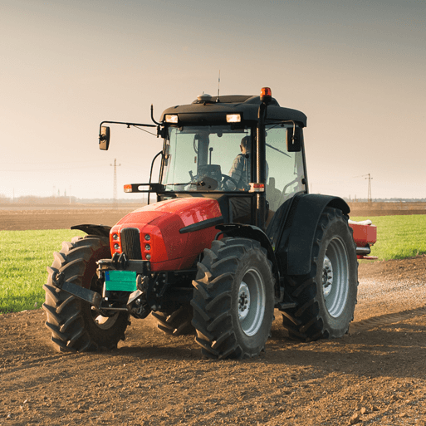

Design and Technology

In art and design this half term our project teaches children about the meaning and benefits of seasonal eating, including food preparation and cooking techniques

Topic: Geography Focus – Sow Grow Farm

In the Sow, Grow and Farm project, your child will learn about allotments in the United Kingdom and how the government encouraged people to have them to support food rationing during the Second World War. They will learn about food webs and animal life cycles, including how living things are dependent on one another within a habitat. They will investigate the different ways that plants reproduce and will dissect flowering plants to identify the different structures. They will have the opportunity to learn about farming in the United Kingdom and the techniques used in modern farming, including the challenges that farmers face. They will learn about the benefits of eating seasonally and about the pros and cons of importing food. They will also learn about world farming and how the different climate zones affect where different foods can be grown.

Reminders

Please ensure children are reading 5 times a week and recording this in their reading diary. Children should also have their reading book in school with them every day so they can be listened to in school.

Homework will be sent out on a Wednesday and should be returned to school on the following Wednesday.

PE kits will be needed every Monday and Thursday.

Writing

This half term we are focusing on persuasive writing We will discuss the features of persuasive texts and begin to look at the issues related to plastic pollution as a stimulus. Once we have looked at the format of a persuasive letter, use of vocabulary, intent on the reader amongst other word and sentence level strands we will begin to plan and write our own persuasive letters to convince the prime minister to do more to tackle the plastic pollution problem!

PE

In PE this half-term, we will be focusing on gymnastics and orienteering. We will be learning how to master the basic skills in both areas such as balancing, movement and travel in gymnastics and map reading, team work and strategy building in orienteering

Science: Living things and their habitats

In science this half term our focus will be all about Living things and their habitats.

We will be looking at sexual and asexual reproduction in plants. We will be dissecting plants, looking at the parts needed in plant reproduction, and we will also be taking cuttings of plants to obseve how they grow.

We will be looking at different life cycles including the life cycle of; mammals, amphibians, birds, and metamorphosis.

Maths and arithmetic

Fractions:

Compare and order fractions greater than 1/ Add and subtract fractions with the same denominator/ Add fractions within 1/ Add fractions with total greater than 1/ Add fractions with total greater than 1/ Add to a mixed number / Add two mixed numbers/ Subtract fractions / Subtract from a mixed number – breaking the whole/ Subtract two mixed numbers/ Multiply a unit fraction by an integer/ Multiply a non-unit fraction by an integer/ Multiply a mixed number by an integer/ Calculate a fraction of a quantity/ Fraction of an amount / Find the whole/ Use fractions as operators.

Multiplication and division:

Multiply up to a 4 digit number by a 1 digit number/ Multiply a 2 digit number by a 2 digit number/ Multiply a 2 digit number by a 2 digit number/ Multiply a 3 digit number by a 2 digit number/ Multiply a 4 digit number by a 2 digit number/ Solve problems with multiplication/ Short division/ Divide with remainders/ Efficient division/ Solve problems with multiplication and division

**Spring 1: Sow Grow Farm**