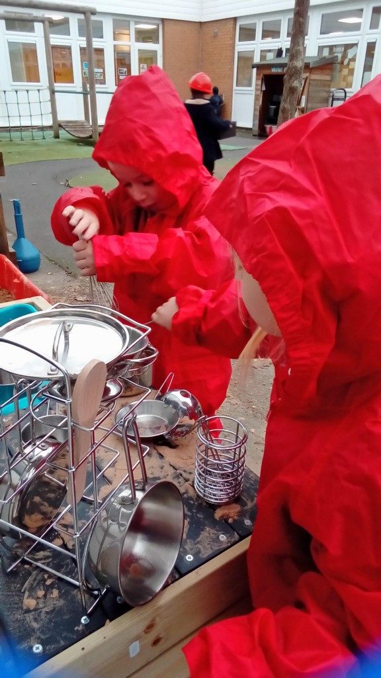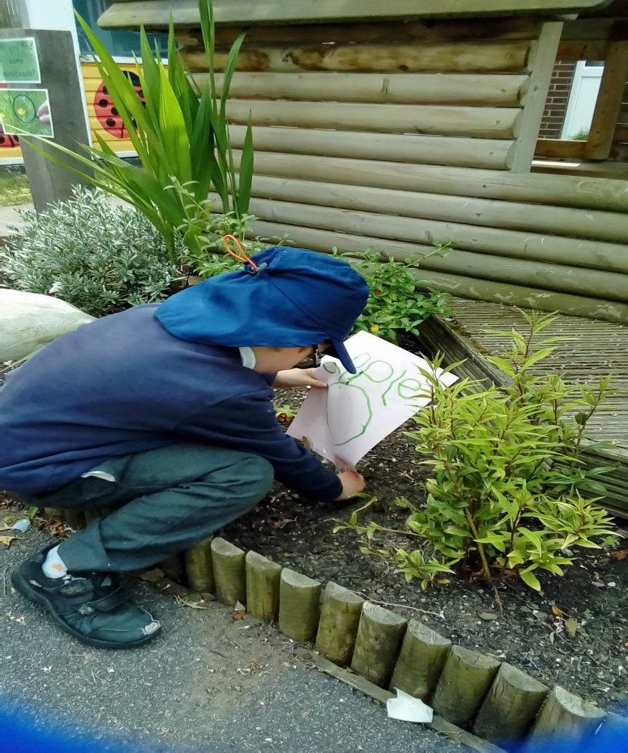

Starting School

Hatchell Wood Primary Academy Information Booklet

**Welcome to Hatchell Wood Primary Academy!**

This booklet contains information to help you and your child prepare for the exciting journey ahead of starting school. You will find all the information you need and some ideas on how to ensure your child is ready for school so they can have a really positive start to their education.

We believe that parents and carers play a significant role in the education of their children and through close cooperation and communication with you we can enhance and enliven the experiences that your child will have in school. In this way we will, together, bring out the very best in your child.

If you have any further questions please do not hesitate to contact us via the school office.

We look forward to welcoming you to our school community.

**School Contact Details:**

**Address:**

Hatchell Wood Primary Academy,

Plumpton Park Road,

Doncaster,

DN4 6SL

**Telephone:**

01302 538108

**Website:**

[hatchellwood.com](mailto:admin@hatchellwood.com)

**Email:**

[admin@hatchellwood.com](mailto:admin@hatchellwood.com)

**Meet the team!**

Headteacher Deputy Headteacher



Mrs F Burton Mrs G Snow

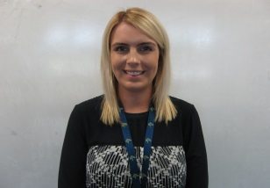

Mrs A Hickey– FS2 Teacher/EYFS leader (Bees Class)



Mrs S Atkinson – FS2 Teacher (Bees/Butterflies Class)

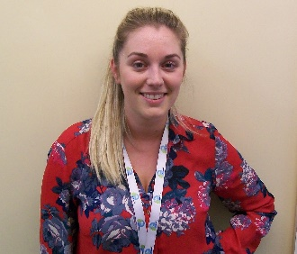

Mrs K Durkin– FS2 Teacher/EYFS Leader (Butterflies Class)

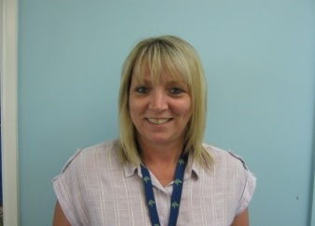

Miss L Fox – Teaching Assistant

**Preparing your child for school**

**How do we help to prepare your child for school?**

We follow a transition program to help children feel settled when they come into school.

This year we will offer various stay and play sessions. You can come with your child to view the setting and have a play! It gives you the opportunity to ask any questions that you may have regarding your child starting school. This will also provide you with a chance to become familiar with the EYFS team and the school.

The sessions will be an opportunity for you and your child to come into school to help them become familiar with the school environment and meet other children who will be starting in their class. If you are unavailable to attend these sessions, a relative or friend is more than welcome to bring them. These are not compulsory.

**How can you help prepare your child for school?**

We have made a list of a few ideas that you can do to help your child prepare for starting school.

* Share books and stories.
* Teach your child nursery rhymes.
* Play turn-taking games such as snakes and ladders; make sure your child learns how to win and lose as well.
* Have play opportunities with other children, especially over the summer holidays.
* Talk about numbers and teach your child to count objects accurately.
* Talk about shapes and colours.
* Encourage your child to dress and undress themselves, including using buttons and zips.
* Ensure your child can manage using the toilet by themselves, including washing their hands afterwards.

**The Early Years Curriculum**

All learning is planned around The Early Years Foundation Curriculum, with the focus being on children learning through play. Experiences are planned around the children’s interests, for example if the children are showing a real interest in dinosaurs we will add dinosaurs for the children to play with and also do some finding out together about them. Therefore it really is very helpful if you can give us an idea about what your child is interested in at home. To support this we have sent out an ‘All about me’ sheet for you to complete so we can get to know the children and their interests.

The Early Years Foundation Curriculum has 3 prime areas, these need to be developed before children can move forward in their learning.

* Communication and language
* Physical Development
* Personal, Social and Emotional Development.

The Early Years Foundation Curriculum also has 4 Specific areas of learning.

* Literacy
* Mathematics
* Understanding the World
* Expressive arts and design

All experiences are planned using these areas. We ensure that the children have plenty of opportunities to play and explore, be active in their learning and create and solve problems.

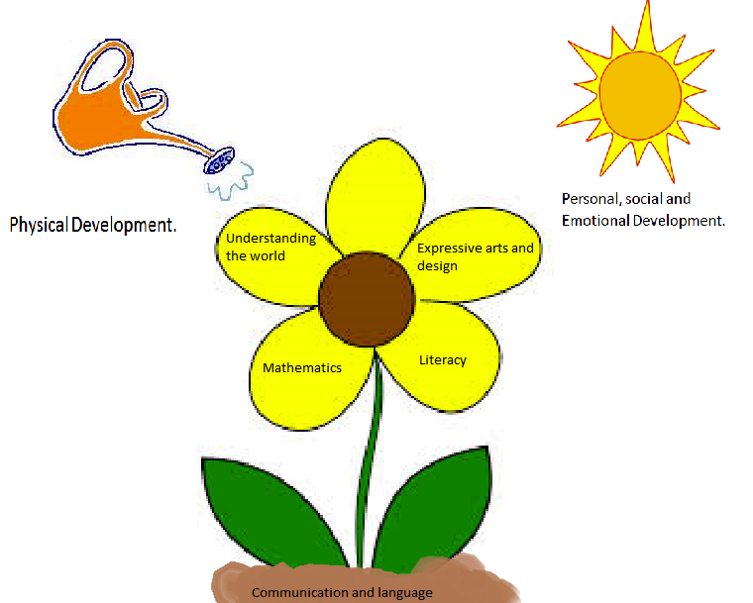

**The importance of play**

Play is the natural way in which children explore and learn. Therefore all the children’s learning in Reception is based on play. We spend a lot of time planning playful experiences which the children take part in. As part of this we have set up areas of learning, these form the basis of everything we do in Reception. These areas will change and develop throughout the year in line with the children’s needs and interests. Below are some photos of some of our current areas.

Writing area Reading area

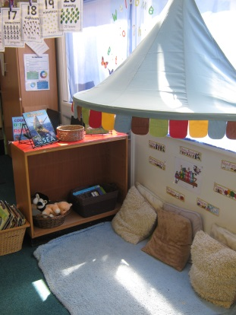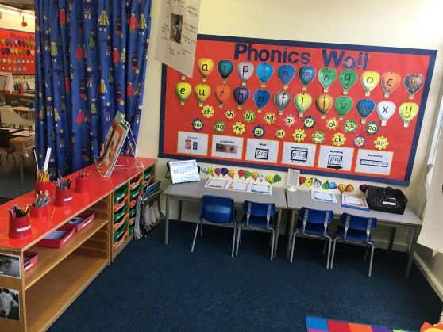

Small world area Indoor Sand area

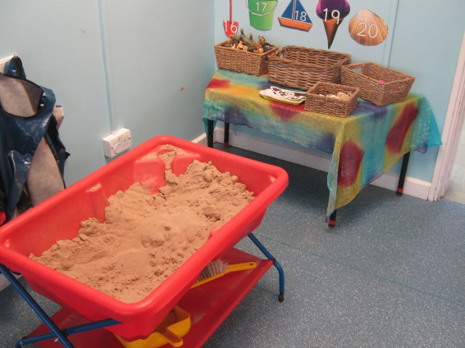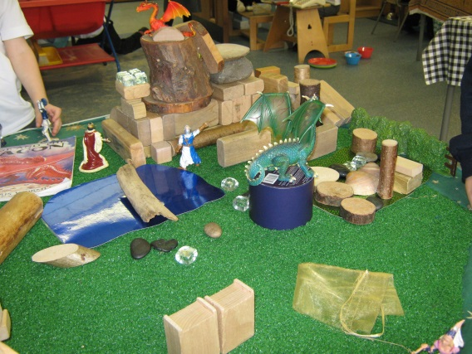

Construction area Maths area

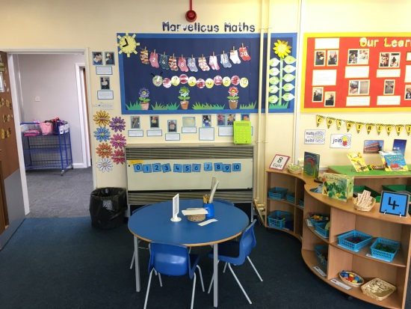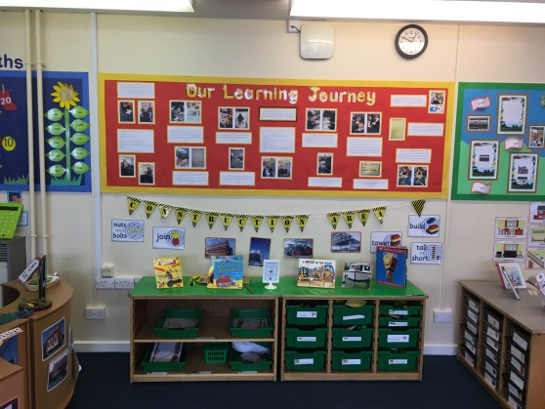

**Outdoor Learning and play**

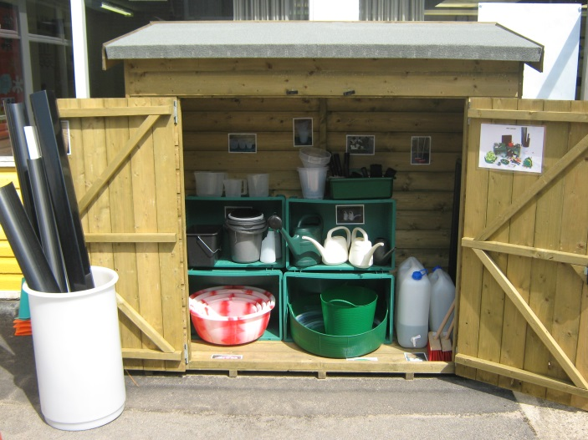We really value the importance of children being outdoors and feel that children learn best from experiences linked to the natural world. The Early Years Foundation Curriculum promotes outdoor play and asks that the children have as much access to this as possible.

Therefore the children will get plenty of opportunities to use our outdoor play space each day, whatever the weather! We have a range of waterproof clothing for the children to wear when exploring outdoors. However, we do ask that you bring your child a pair of wellingtons into school with their name on so that they can use them outdoors. We will talk with the children about the world around them and encourage them to take part in a wide range of outdoor activities. On occasions we may also take the children on walks around the local area we will let you know before this happens.

***‘All children have the right to experience and enjoy the essential and special nature of being outdoors. Young children thrive and their minds and bodies develop best when they have free access to stimulating outdoor environments for learning through play and real experiences.’***

Here are some examples of the kinds of activities and learning the children will experience in the different areas outdoors. They are able to use a range of skills including imagination, teamwork, problem solving and working independently.

Den and Camping Water play

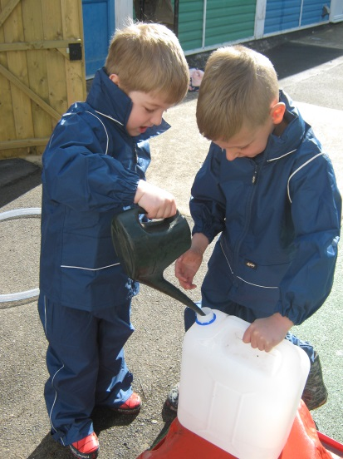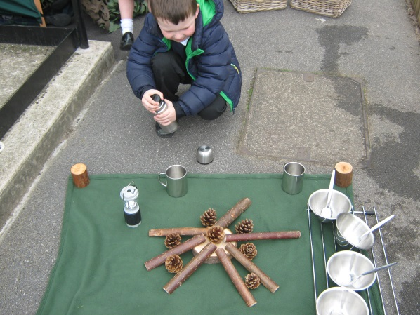

**Supporting your child with their learning**

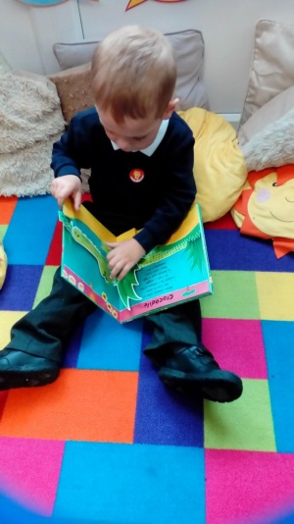Parents always ask what they can do to help support their child with learning at home so we have put some advice and tips together to ensure you can fully support your child throughout their first year at school.

We ask all parents to read with their children as often as possible. We feel this is one of the most important things you can do to support your child. This can include reading stories to your child as this helps them to develop a love of reading along with promoting a range of vocabulary. This also helps to build children’s understanding and support with writing. We also ask that you hear your child read to you for 5-10 minutes a day to help them grow in confidence. We encourage all parents to set aside some time each day to hear their child read.

We will also provide information in the autumn term which will focus on reading and phonics.

We also use an online learning journal to record your child’s learning and journey during their first year at school. Assessment plays an important part in helping parents, carers and staff in school to recognise children’s progress, understand their needs, and to plan activities. We have chosen to use Tapestry which is a website that can be accessed on a computer or laptop, and also any Apple or Android device such as a tablet or smartphone. Instead of using the old paper book style way of recording, we will be able to instantly upload photos, videos and observations of your children. You are then emailed to alert you that something new has been added to your child’s Learning Journal and can log on and view what your child has been up to.  A massive advantage of this system is that you can instantly add your own comments to entries, and can show your child’s online book to members of the family. We also encourage you to add any photographs of things you have done at home as this is a great opportunity for your child to share with their class and teacher!

**General Information**

**The School Day**

Registration and lessons for Foundation Stage Two (Reception) and Key Stage 1 children start at 8.40am and finish at 3.00p.m. The doors to the cloakrooms will be open at 8:30am and children can be dropped off between 8:30-8:40am.

The reception teachers, Mrs Atkinson, Mrs Hickey and Mrs Durkin will be in the playground and will guide the children into the cloakrooms and then safely into the classroom. Please try to say goodbye to your child in the playground as this encourages the children to become more independent by coming into school on their own.

If you arrive after 8.40am the classroom doors will be closed and you will need to go to the main entrance.

**Attendance/ Illness**

It is very important that children attend school every day so that they can make good progress in their learning. If your child is unwell and, as a result, will be absent from school it is your responsibility to ring the school office that morning to inform us of the reason for absence every morning of illness.

Generally speaking, if your child is unwell they should not be at school. The school day is too demanding if you are not well and of course, there is every possibility they will pass on their illness.

* Only medicines prescribed by the doctor/pharmacist in their original containers with names on, can be administered by school staff.
* We will administer 4 dose-a-day antibiotics if your child is well enough to return to school but needs to finish the course. If the dose is three times a day they should try to be organised before and after the school day.
* Asthmatic inhalers are stored safely for those who need them. We ask that you request from the doctor an inhaler to be left at school.
* If your child needs any medication at all a parent must complete a medication form.

**First Aid**

The vast majority of accidents are very small and a plaster is sufficient. Occasionally, a child will have a more serious accident and we will ring you. Do make sure that you always keep your phone and contact numbers up to date. Any first aid that is carried out is recorded and you will receive a notification via email.

**School Uniform**

Wearing school uniform enables pupils to feel a sense of belonging and pride in their school. It also establishes a clear identity within the local community. Please click on the link below to order school uniform with the logo on:

[www.myclothing.com](http://www.myclothing.com/)

There is no obligation for parents to purchase uniform bearing the school logo. All we do ask is that parents adhere to school colours.

School uniform is as follows:

**Girls**

* Grey or black pinafore dress, skirt or trousers
* White blouse or polo shirt
* Summer if desired, blue and white striped or gingham checked dress
* Navy sweatshirt or cardigan with or without school logo
* Black shoes (no trainers)

**Boys**

* Grey or black trousers (short trousers for summer)
* White shirt or polo shirt
* Navy sweatshirt with or without school logo
* Black shoes (no trainers)

**PE**

PE is an important part of our school curriculum and children will take part in weekly sessions. Children will be asked to bring their PE kit on their PE day so they can get changed (You will be informed of what day this is in September). Your child’s PE kit should include:   
• Dark coloured shorts/trousers

• Plain white T-shirt

• Pumps / trainers (preferably without laces)

If your child has earrings, they need to be removed or covered on their PE day.

**Labelling School Uniform**  
Please ensure that you clearly label all your child’s belongings with their name. This is of great assistance in enabling us to return lost items to their rightful owner.

Unnamed items are placed in the lost property box. Any items which remain unclaimed at the end of each term will be disposed of.

**Book Bag**

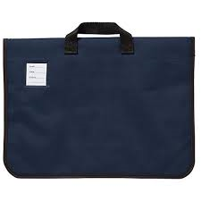

Children will need to bring a book bag to school each day for their reading book, any home learning activities and for letters. Letters will usually be sent out electronically but in some cases we may need to send a paper copy. It is always worth checking your child’s book bag for this.

Over the first half term we will add the following to your child’s book bag:

**My reading book**

When we get into the full swing of things the children will bring their reading book home most evenings. Please, make that all important 5 or 10 minutes for your child every day. This will usually start with a picture book to encourage rich language, speech and imagination.

**Little Wandle Phonics Flashcards**

Once we start to teach letters, sounds and words your child will bring home a list of sounds/tricky words. In this they will have words that they need to read and letter sounds. Please use these as much as possible at home to help your child recognise letter sounds and words. Information will be sent in the autumn regarding pronunciation and delivery of this.

**A Typical Day**

Here are some activities that your child may do as part of their daily routine.

* Circle Times – to begin with, the children start their day with circle time. They can share what they have been doing at home and school and talk about how they are feeling and classroom rules and their learning skills.
* Playing to Learn – Children talk about which area of the classroom they are going to play in and what they are going to do or make. They then discuss what they have learnt during review time.
* Literacy, Phonics and Maths- Large and Small Group Times
* P.E – the children will take part in a P.E session once a week, they will need their P.E kit. We will inform you of your child’s P.E day in September.

**Playtimes**

The reception children will be gradually introduced to the playtime routines over the first few weeks. Some children can’t wait to get out there and others find it a little daunting. Staff are aware of this and will be keeping a special eye out for our new children.

There are three playtimes during the day: morning play, dinner play and afternoon play. The children will join Key Stage 1 children at morning and afternoon breaks and the rest of the school at dinner play. The playground is split into Key Stage 1 and Key Stage 2 children at lunch time so the children in reception will play on the Key Stage 1 side of the playground.

FIRST AID: There is a First Aider on duty for all playtimes.

WEATHER: Only really heavy rain and occasionally high winds keep us indoors over playtime. If it is only spitting with rain, we still go out for a race around in the fresh air – it is much healthier than staying cooped up all day. The children should come appropriately dressed, always bring a coat!

**Lunchtimes**

All children in Reception, Year 1 and Year 2 are now entitled to free school meals.

**SCHOOL DINNER:** This is a lovely social occasion. The children learn to share and take turns. The children learn to use a knife and fork and they learn basic table etiquette.

Our lunch time supervisors are lovely with the children and they make every effort to ensure that the children are comfortable and enjoying their meal. No-one is made to eat anything! However, just as you would do at home, we encourage the children to try new things to see if they like it. Our cooks are lovely too. We have a system where you can choose what meals your child would like for the following weeks lunch. If you don’t choose one, they will be given the ‘regular’ meal for that day.

**Snack/milk time**

All children in reception and Key stage 1 are provided with a free healthy snack consisting of fruit or sometimes vegetables, such as carrots, each day. A National Fruit and Vegetable Scheme has been running for a number of years, which means that this is free of charge. As with dinners, no-one is forced to eat anything they really don’t like but we do encourage the children to have a try and promote a positive healthy attitude. We are sent apples, satsumas, pears, tomatoes, carrots, bananas; one type of fruit per day. In the summer we even have strawberries as a special treat.

The children will all need a water bottle so they can help themselves to a drink of water should they feel thirsty during the day.

Children in Reception are also entitled to free carton of milk until they are 5, for those who enjoy a milk drink.

**You will need to pay the cost of the milk when your child turns 5 years old. For more information please visit** [**www.coolmilk.com**](http://www.coolmilk.com)**.**

**Home time**

At home time we bring the children to the door and look for you. From day one the children are told ‘Stay with me until we call your name and we can see your grown-up.’ Do put the school number (01302 538108) into your mobile and then if you are late for any reason you can let us know. Don’t panic, your child will be safe and supervised until you arrive. As part of our ongoing commitment to ensuring the safety of the children we also operate a password system. If your child is collected by someone other than the usual person then a password will be required by this person. In order to avoid any difficult situations, please make sure the adult collecting your child is made aware of this important safeguarding procedure.

If you are late, after about 3.10pm, the children will be waiting with staff at the main entrance so please use that door.

Some of you will have child minders and sometimes grandmas and grandads will pick up from school. If it is a long term arrangement e.g. a child minder, it is helpful for us to have that information in writing. For occasional changes to routine you can send a note or just let us know in the morning.

If older siblings are collecting children from school, please note they need to be 16 years of age or older.

**Open Door Policy**

We have an open door policy in school, meaning that teachers are available for a conversation in the mornings and at the end of the day after they have seen the children to their responsible adult. We encourage parents to discuss any questions or concerns that they may have about their child with their class teacher.

For further information please visit the school website, ask to speak with the Early Years Team or contact the school office who are always happy to help.

We look forward to welcoming you in September.

The Early Years Team