Pupil premium strategy statement 2023-2026

This statement details our school’s use of pupil premium funding (and recovery premium) to help improve the attainment of our disadvantaged pupils.

It outlines our pupil premium strategy, how we intend to spend the funding in this academic year and the effect that last year’s spending of pupil premium had within our school.

School overview
Detail | Data
School name | Hatchell Wood Primary Academy
Number of pupils in school | 418
Proportion (%) of pupil premium eligible pupils | 124 pupils 29.7%
Academic year/years that our current pupil premium strategy plan covers | Year 2 of 3 – 2024/245  (Full strategy 2023-2026)
Date this statement was published | 01.09.24
Date on which it will be reviewed | 01.09.25
Statement authorised by | F Burton
Pupil premium lead | C Reade
Governor / Trustee lead | J Bullock
Funding overview
Detail | Amount
Pupil premium funding allocation this academic year | £139,680
Recovery premium funding allocation this academic year | £14,500
Pupil premium funding carried forward from previous years (enter £0 if not applicable) | 0
Total budget for this academic year | £154,180

Part A: Pupil premium strategy plan

Statement of intent
At Hatchell Wood Primary Academy, our aim is to ensure that our teaching and learning meets the needs of all pupils, helping them to achieve their individual potential. The Pupil Premium funding enables us, starting with quality first teaching, to ensure that we provide extra provision for any pupils who fall into this group. We diagnostically assess and address their individual needs through challenge and engagement to reach their full potential. This may be academic support in areas where they have gaps in learning or where learning has not been embedded and so it needs to be revisited and reinforced. We also focus on mental health and wellbeing support so that the children are ready to learn through developing learning skills and resilience or are more able to process difficult events in their life.

Challenges

This details the key challenges to achievement that we have identified among our disadvantaged pupils.
Challenge number | Detail of challenge
1 | Some pupils are not working at age related levels and have conceptual gaps or misconceptions.
2 | Some children have limited speech and language and/or vocabulary skills. Assessments, observations and discussions evidence this.
3 | Some pupils need to develop their skills for learning, including resilience, retrieval, self-regulation and independence.
4 | Consistent attendance and punctuality is a key priority for all children. Persistent absence for PP children is 13.35% higher than non pp children
5 | Some children have limited life experiences no wider than their home and community network. We need to develop enrichment opportunities and ensure these are accessible to all. This has been evidenced by Thrive screening and observations/discussions with pupils.
6 | A positive working relationship between school and families is crucial to supporting a child’s all round development; further development of relationships with families would help us to close the gap in learning

Intended outcomes
This explains the outcomes we are aiming for by the end of our current strategy plan, and how we will measure whether they have been achieved.
Intended outcome | Success criteria
Improved attainment for disadvantaged pupils | Achieve above national average progress scores in combined KS2 data
Improved vocabulary, language and oracy skills that impact on reading and writing progress across all year groups | Improved outcomes in Year 1 and end of Year 2 phonics testing for all pupils  Decrease in the number of pupils accessing phonics interventions
To improve skills for learning for all pupils in our school particularly our disadvantaged and vulnerable pupils | Thrive screening shows an improvement in children’s social and emotional health on an individual, class and school measures
To improve the attendance of pupil premium pupils with an increased understanding of the importance of attendance specific focus on persistent absence | Attendance at or above 96% for all groups of pupils and to see a decrease in PA figures
To improve engagement with families of all pupils and increase participation in wider curriculum and enrichment opportunities | Improved attendance for disadvantaged pupils at clubs/trips/visits

Teaching (for example, CPD, recruitment and retention)
Budgeted cost: £ 54,180
Activity | Evidence that supports this approach | Challenge number(s) addressed
Embed metacognitive strategies into the curriculum to support retrieval and address gaps in knowledge.  Develop the use of Padlet in classrooms through training, CPD, etc | EEF – Metacognition and Self-Regulation Research and Guidance Report.  Metacognition and self-regulation | EEF (educationendowmentfoundation.org.uk)  Metacognition – very high impact, low cost Teaching and Learning Toolkit | EEF (educationendowmentfoundation.org.uk)  Effective professional Development - EEF | 1, 2,
Assistant Head to take on Literacy lead role from September with key focus on Oracy (whole school oracy plan to be created) | EEF Guidance Report – Improving Literacy in KS1 https://d2tic4wvo1iusb.cloudfront.net/production/eef-guidancereports/literacy-ks1/Literacy_KS1_Guidance_Report_2020.pdf?v=1688966443  EEF Guidance Report – Improving Literacy in KS2 – https://d2tic4wvo1iusb.cloudfront.net/production/eef-guidancereports/literacy-ks2/EEF-Improving-literacy-in-key-stage-2-reportSecond-edition.pdf?v=1688960393
Fully develop the use of Starr Assessment as a whole school assessment tool to track the attainment of all pupils regardless of starting points. Staff training, CPD, development of assessment lead role, etc. | ‘Renaissance assessment and practice solutions are recognized by national educational organizations and publications dedicated to ensuring all students receive an outstanding education.’  Starr Assessment | 1
Staff CPD focused on metacognative practices linked to retrieval skills to ensure quality first teaching and teaching methods aligned with how children learn. | There is vast amount of evidence to suggest that metacognitive practices are one of the most impactful pedagogical strategies to help support independent, self efficate learners.  ‘The Great Teaching Toolkit’ – with particular reference to the ‘Activating Hard Thinking’ section https://www.greatteaching.com/  https://educationendowmentfoundation.org.uk/education-evidence/guidance-reports/metacognition | 1, 2, 3,
Use of Let’s Think in English across school to develop reading, comprehension, and speaking and listening skills. Training and CPD for staff, time out of class to observe each other, etc | LTE also impacts on reading comprehension, low cost, high impact  Teaching and Learning Toolkit | EEF (educationendowmentfoundation.org.uk) | 1, 2
Use of Launchpad for Literacy Programme. Launchpad for Literacy is all about children, the skills they have and the skills they need for all aspects of literacy . | It is a systematic, skill-based approach providing a diagnostic tool kit to identify barriers to learning.  LaunchPad website | 1, 2

Targeted academic support (for example, tutoring, one-to-one support, structured interventions)
Budgeted cost: £ 30,000
Activity | Evidence that supports this approach | Challenge number(s) addressed
New assistant Head role with specific focus on assessment and narrowing the attainment gap (1 day out of class) this will be a role involving mentoring and coaching other staff to motivate and support them. | EEF guidance report on Effective Professional Development shows clear evidence that coaching and mentoring is an effective way to support and has a positive impact.  https://educationendowmentfoundation.org.uk/educationevidence/guidance-reports/effective-professional-development | 1, 2, 3, 4
Small group and/or one to one tuition with particular focus on (dependent on year group) phonics, reading, writing arithmetic/basic maths skills. These will be taught by experienced qualified teachers/TA | Meta-Analysis of research by John Hattie breaks down quality teaching into: Pupils having clear goals/objectives. Teachers providing pupils with modelling/scaffolding/appropriate steps to achieve them. | 1, 2
Reading Assessment Programme to be delivered for disadvantaged pupils to bridge gaps in knowledge | FFT's Reading Assessment Programme is a simple and effective online assessment tool designed to assess pupils on their GPC Accuracy, Decoding Accuracy and Fluency Levels  https://fft.org.uk/literacy/reading-assessment-programme/ | 1, 2
Little Wandle interventions – fluency, catch up – specifically identified interventions through tracking of phonics data | Rapid Catch-up lessons use the same content as the core programme delivered at a quicker pace, these ensure children can grow their language and become fluent readers  https://www.littlewandlelettersandsounds.org.uk/ | 1, 2

Wider strategies (for example, related to attendance, behaviour, wellbeing)
Budgeted cost: £ 70,000
Activity | Evidence that supports this approach | Challenge number(s) addressed
Thrive Learning Mentor and 1 to 1 support work on children’s individual action plans Whole school Thrive – Thrive assessments for all pupils to identify social and emotional needs and develop class/individual plans to develop organisation, commitment, resilience and self regulation | Thrive Pupils are supported with their individual emotional needs as identified through Thrive assessments. ‘Scientists have discovered that the neural pathways of the brain and wider nervous system are relatively unformed at birth, undergoing much of their development during the first three years of life in response to relational experiences with primary caregivers. A key development during this period is the establishment of the body’s stress response system. It remains possible to intervene at a later stage to fill the gaps if this is under developed’ | 3
Attendance officer and Deputy head work as a team to focus on attendance and track persistent absenteeism. Attendance monitored at class level through vulnerability trackers. Tracking and actions put in place with short term goals. | https://assets.publishing.service.gov.uk/government/uploads/system/uploads/attachment_data/file/1099677/Working_together_to_improve_school_attendance.pdf | 4
Develop the role of parent family support worker within school to further strengthen relationships with families | Parental engagement has a positive impact on average of 4 months’ additional progress – EEF.  https://educationendowmentfoundation.org.uk/education-evidence/guidance-reports/supporting-parents | 3, 4, 6,
Subsidise trips and ensure that all clubs, trips and visits are accessible to all pupils | LOTC evidence  The EEF found that breakfast clubs that offer a free and nutritious meal before school can boost reading, writing and maths results by the equivalent of two months progress per year | 5
Develop role of enrichment lead to plan more varied extra-curricular opportunities for pupils | https://educationendowmentfoundation.org.uk/education-evidence/guidance-reports/primary-sel | 3, 5, 6

Total budgeted cost: £ 154,180
Part B: Review of outcomes in the previous academic year

Pupil premium strategy outcomes
This details the impact that our pupil premium activity had on pupils in the 2023 to 2024 academic year.
Below is a summary of our 2024/2025 outcomes:
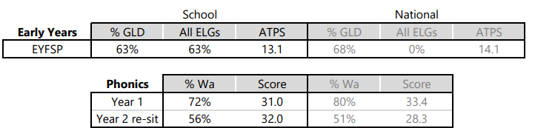
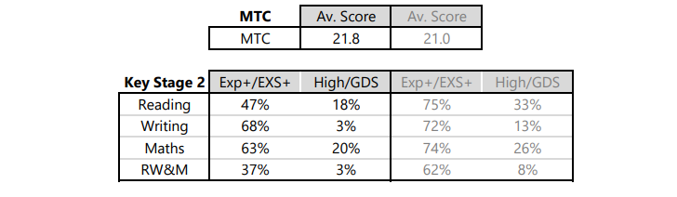
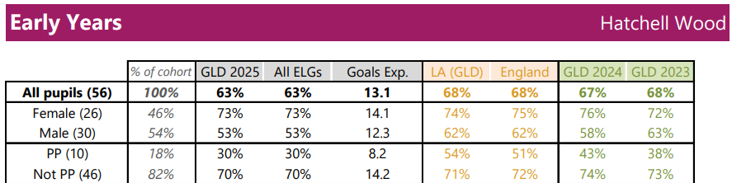
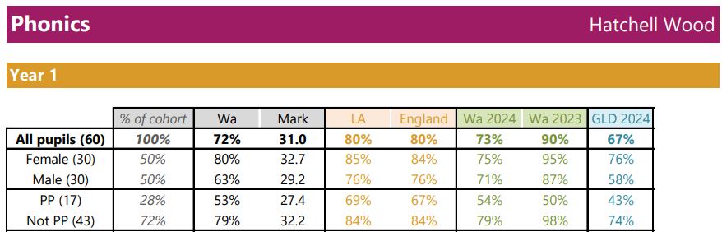
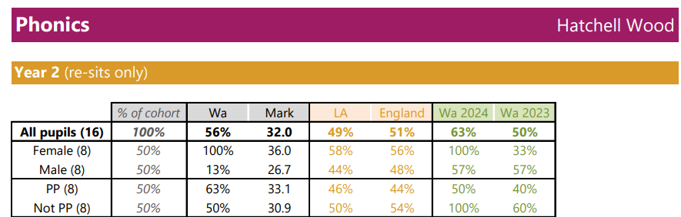
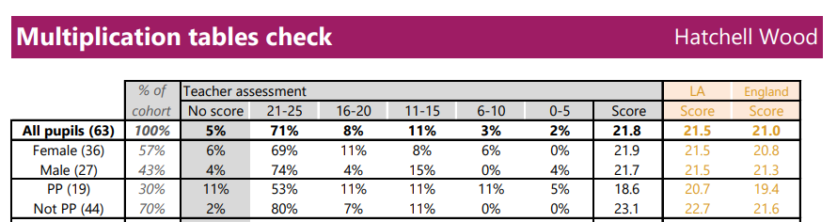
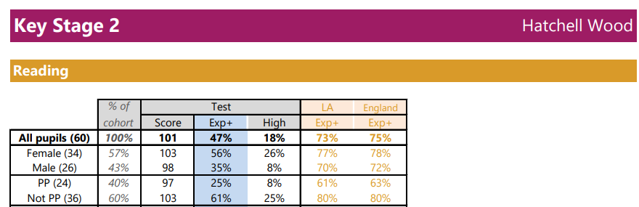
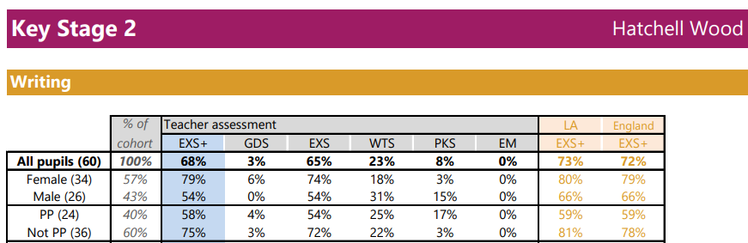
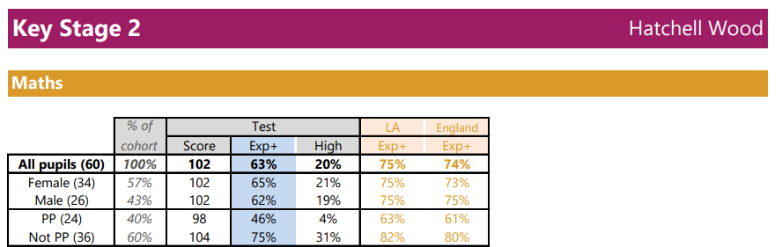
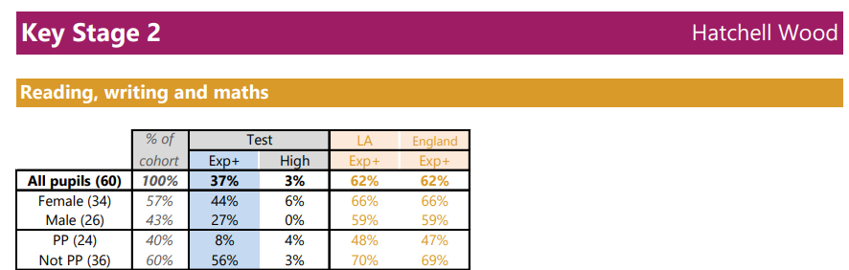
While this year’s results showed good progress had been made for many learners from their individual starting points, the overall outcomes, particularly in Key Stage 2, reflect the ongoing challenges faced by our most disadvantaged learners. In response, we will review the support provided for the final year of the strategy and ensure it focuses on providing targeting intervention support to those that need it most, as well as pastoral care to support our pupil premium children to be fully able to access learning. Closing the gap remains a top priority, and we are committed to working in partnership with staff, families, and external agencies to ensure that all our pupils reach their full potential.

Externally provided programmes
Please include the names of any non-DfE programmes that you purchased in the previous academic year. This will help the Department for Education identify which ones are popular in England
Programme | Provider

Service pupil premium funding (optional)
For schools that receive this funding, you may wish to provide the following information:
Measure | Details
How our service pupil premium allocation was spent last academic year
The impact of that spending on service pupil premium eligible pupils

Further information (optional)

