Coping skills for Kids.

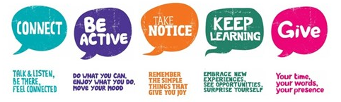
Kids experience a vast array of feelings, just as adults do. They can feel bored, anxious, sad, disappointed, embarrassed, and scared—to name a few. While most of us experience any number of emotions from day to day, we are not necessarily taught how to deal with them or how to cope.
Kids need to learn skills to manage their emotions in a healthy way. It’s important to teach them coping skills that can help them face their fears, calm themselves down, and cheer themselves up.

Why Kids Need Coping Skills
Without healthy coping skills, kids are likely to act out—essentially sending a message that says, “I feel out of control so I’m going to act out of control.” Kids who don’t know how to deal with their feelings are also more likely to turn to unhealthy coping strategies. Here are a few coping skills that may help.

(Very well family 2020)

Emotion-Focused Coping Skills
Emotion-focused skills may involve your child doing things that help them feel better (like calming down when she is angry or cheering up when she is sad). However, these skills might also involve doing something that offers a temporary distraction so he can return to the issue when she’s feeling more level-headed (like taking a quick break when she’s feeling frustrated). The following are some healthy emotion-focused coping skills for kids.

Labelling Feelings
Strong emotions can be scary for kids, and they can fuel strong reactions. But when children are able to talk about how they’re feeling and what may be causing it, their emotions can feel more manageable. Below are some statements that may help:
- “How are you feeling right now?” Offer them the words to use, like mad, sad, frustrated, scared, worried or embarrassed.
- “Where are you feeling it in your body?” They may say there belly feels tight, there heart is racing or there head feels hot.
- Using “I am wondering or I can see “language will help those children who struggle to recognise their own emotions, and with time they will learn to verbalise their needs.
- NEVER try to find the cause of big emotions until both YOU and the CHILD is calm.
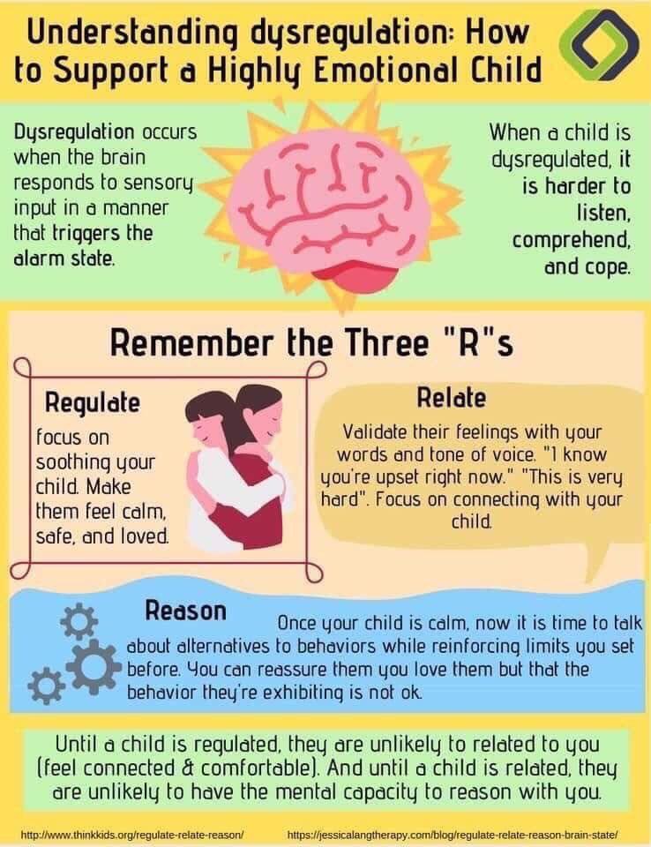
(Think kids. Org 2019)
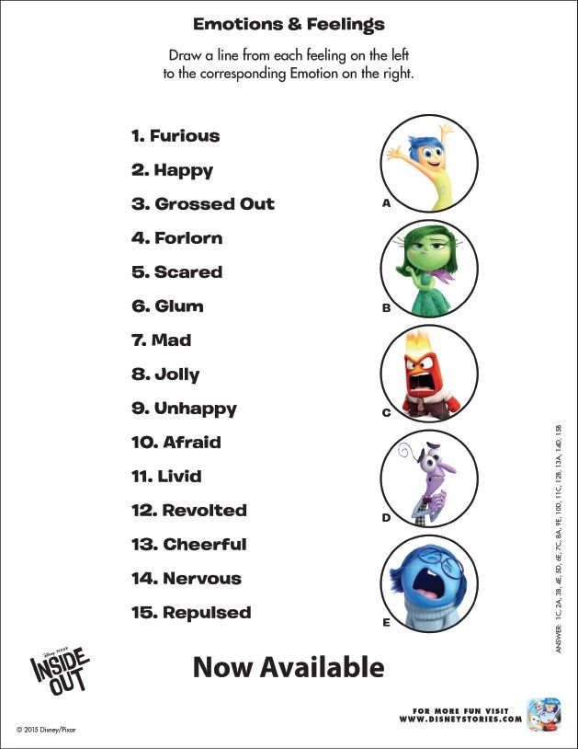

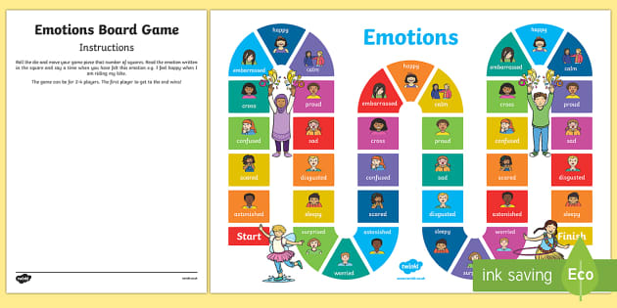(Twinkle 2020)

Breathing Exercises
A few slow, deep breaths can help kids relax their minds and their bodies. One way to teach kids to do this is by encouraging them to take “bubble breaths.” Tell your child to breathe in deeply through her nose and then breathe out slowly through her mouth like she’s trying to blow a bubble with a wand.
An alternative strategy is to teach your child to “smell the pizza.” Tell her to breathe in through her nose like they are smelling a piece of pizza. Then, tell them to blow on the pizza to cool it down. Encourage your child to do this several times to help her feel better.
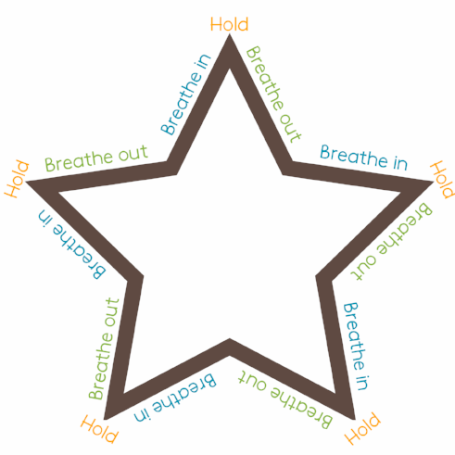
(coping skills for kids 2017)

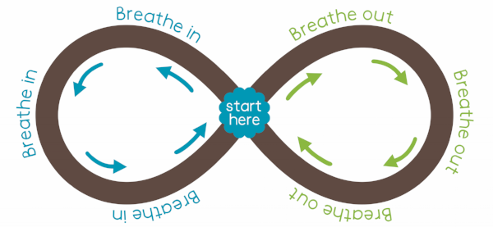
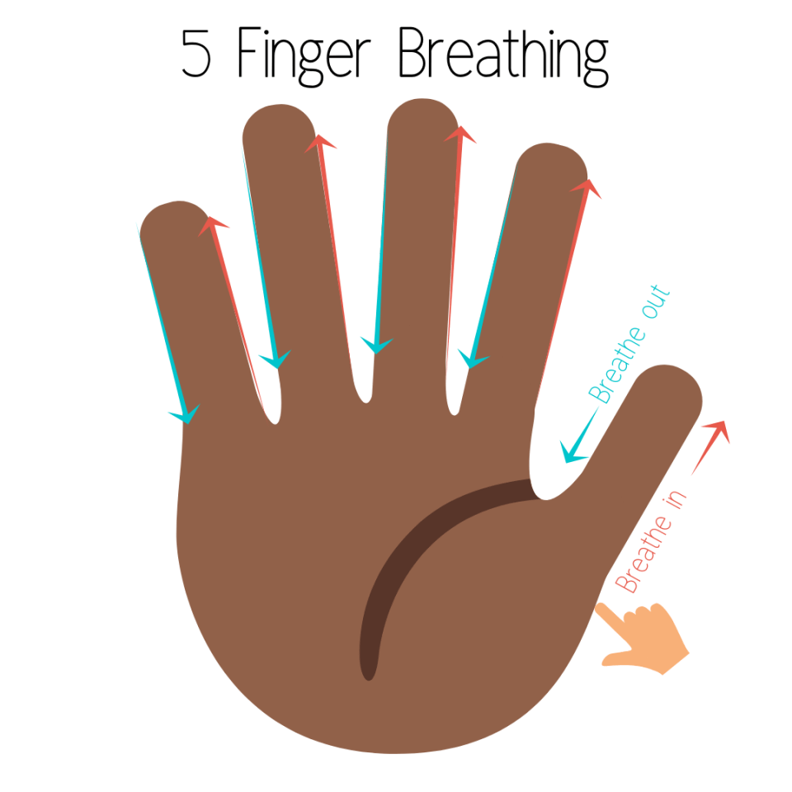(The clam corner 2018)

Exercising
Exercise can be a great way for kids to get out their excess energy when they are nervous and to boost their mood when they are down. Strength building exercises (like lifting weights) and aerobic exercise (like running) can be excellent ways to help kids regulate their emotions. Exercise can be done anywhere using an array of objects. For example simple push ups against a wall, Jumping jacks, skipping, bouncing on a trampoline to name a few can all be done at home.
(Verywell family 2020)
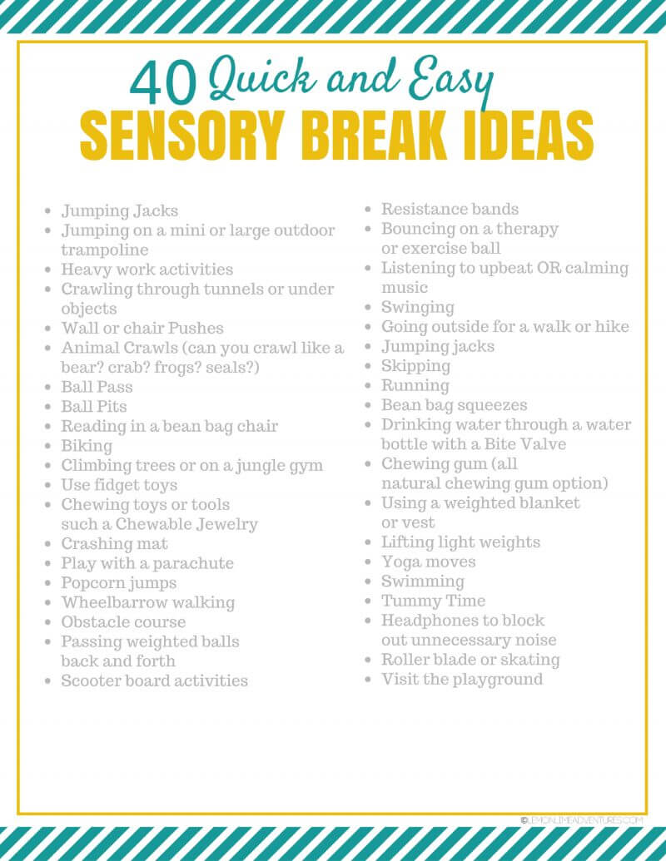(lemon lime adventures 2020)

Getting creative
Whether your child enjoys painting with water colours, colouring in a colouring book, doodling, sculpting with clay, or creating a collage, art work can be an excellent coping strategy. Drawing out there feelings is another good way children can learn to communicate.

Reading
Reading books can serve as a great temporary distraction. When your child is done reading, she might feel better equipped to tackle a problem because she’s feeling calm and rejuvenated.

Playing a Game
If your child can’t stop thinking about something bad that happened at school or something he’s dreading in the future, do something to get his mind off his concerns.
Whether you play a board game or kick around a ball outside, doing something active can help change the channel in his brain. Then, he’ll be able to think about other things, rather than dwell on all the things that make him feel bad.

Yoga/mindfulness
Yoga provides many benefits to the mind and the body.
And when your child needs a boost in mood or needs help relaxing, you can remind her to practice some of her yoga poses. Simple mindfulness provides children with simple, practical tools to work directly with their nervous systems, helping them regulate emotional states and focus attention. Mindfulness gives children the tools to focus their minds, calm down and reflect on a situation when they need to make a choice.

Body Scan
The body scan is a key practice in mindfulness, and an easy one to teach to children.
- Have your kids lie down on their back on a comfortable surface and close their eyes;
- Then tell them to squeeze every muscle in their body as tight as they can. Tell them to squish their toes and feet, squeeze their hands into fists, and make their legs and arms as hard as stone;
- After a few seconds, have them release all their muscles and relax for a few minutes;
- Encourage them to think about how their body is feeling throughout the activity (Roman, 2015).
This simple exercise gets kids to be more aware of their bodies and helps them find a way to be present in the moment.
(Verywell family2020)

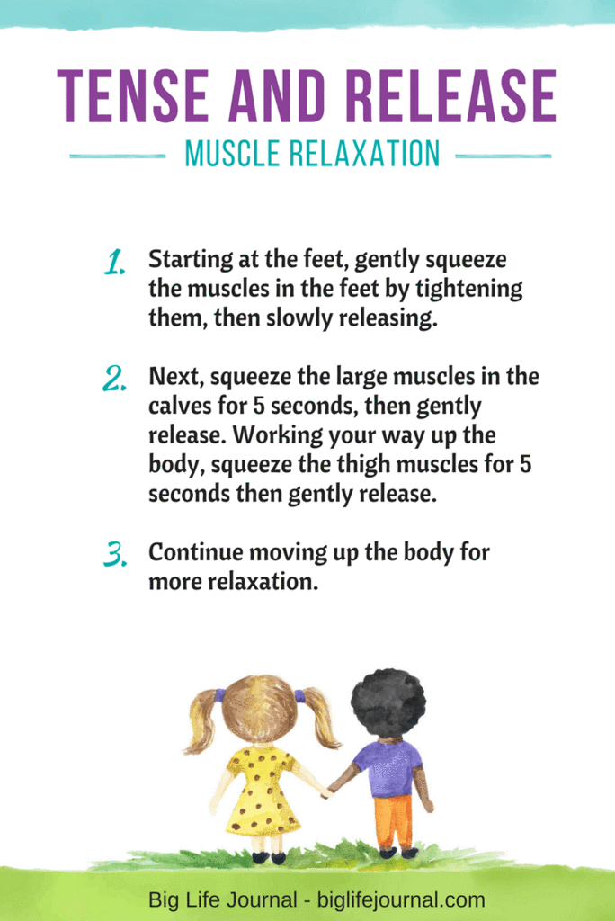
(Big Life Journal 2019)

Heartbeat Exercise
Paying attention to one’s heartbeat has a role in many mindfulness exercises and activities. To begin, tell your kids to jump up and down in place or do jumping jacks for one minute.
When they have finished, have them sit down and put a hand over their heart. Instruct them to close their eyes and pay attention only to their heartbeat and, perhaps, their breath as well (Roman, 2015).
This exercise teaches children to notice their heartbeat, and use it as a tool to help their focus. These skills will come in handy as they start engaging in more advanced mindfulness activities.
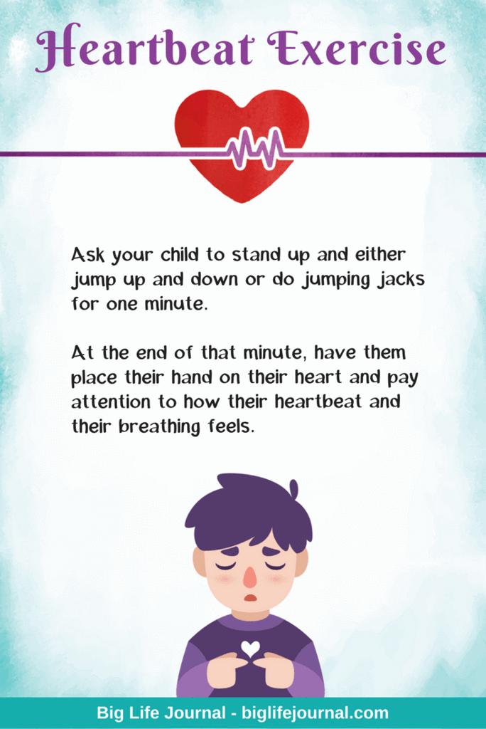(Big Life Journal 2019)

Mindful Breathing
Mindful breathing is a staple of practicing mindfulness. It is the foundation of many other exercises.

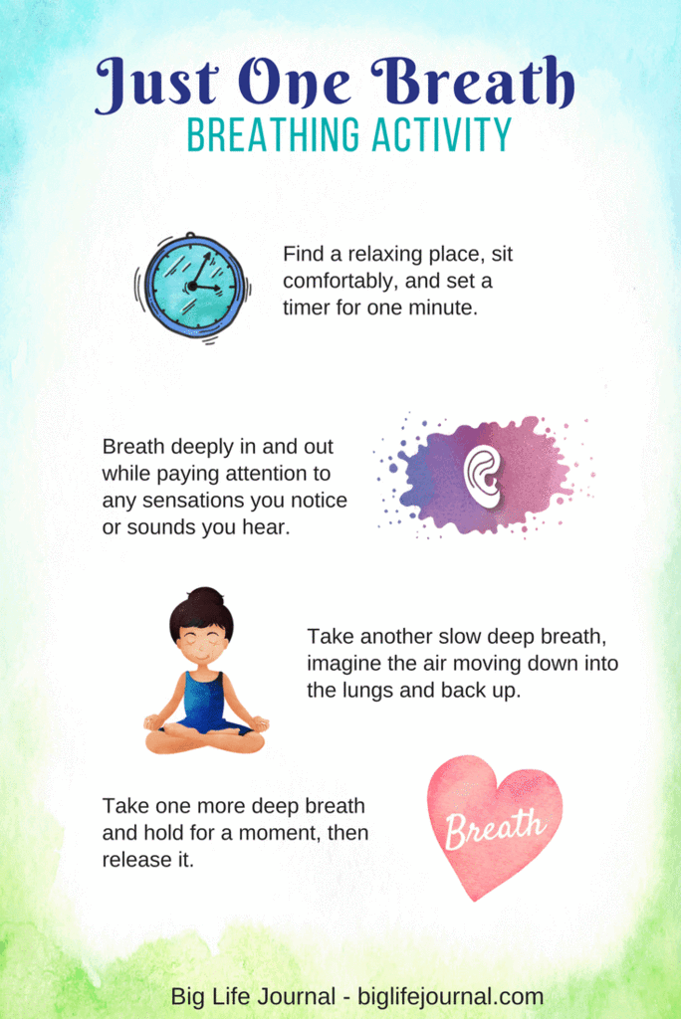(Big Life Journal 2019)

Playing Music
Whether your child likes to make their own music on a keyboard or they enjoy listening to calming songs, music can affect his brain and his body. Music is often incorporated into treatment programs for physical health, mental health, and substance abuse problems because it has been shown to speed healing, calm anxiety, and reduce depression.
Help your child discover how music can be helpful to them. Are there songs that calm him down? Does certain music cheer them up?

Watching a Funny Video
Laughing is a good way to take a mental break from problems. Watching a funny animal video, a hilarious cartoon, or something you captured on video could be a great way to help him feel better.

Positive Self-Talk
When your child is feeling upset, there self-talk is likely to become quite negative. They may think things like, “I’m going to embarrass myself,” or “None of the other kids are going to talk to me.”
Teach them how to speak to themselves kindly by asking, “What would you say to a friend who had this problem?” They are likely to have some kind, supportive words. Encourage them to give those same kind words to self.
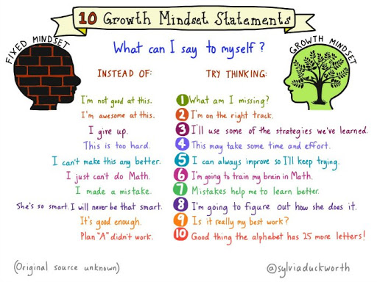(Pintrest 2020 original source unknown)
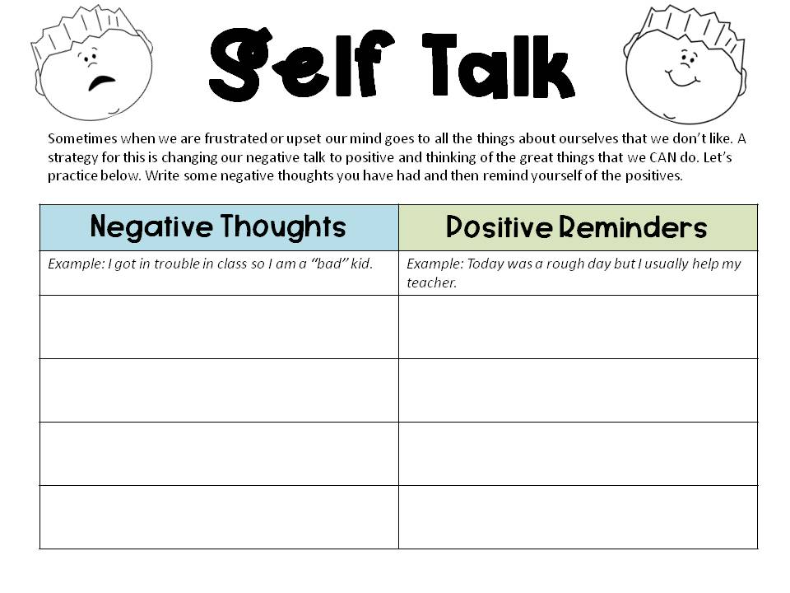(The stylish school counsellor 2014).
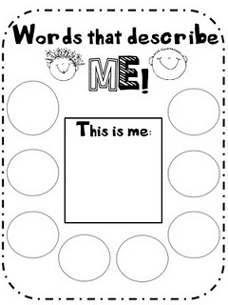(What the teacher wants 2016)

Engage in a Mood Booster
Work with your child on making a list of all the things they likes to do when they are happy—such as do a dance, sing, kick a ball, or tell jokes. Those are his mood boosters.
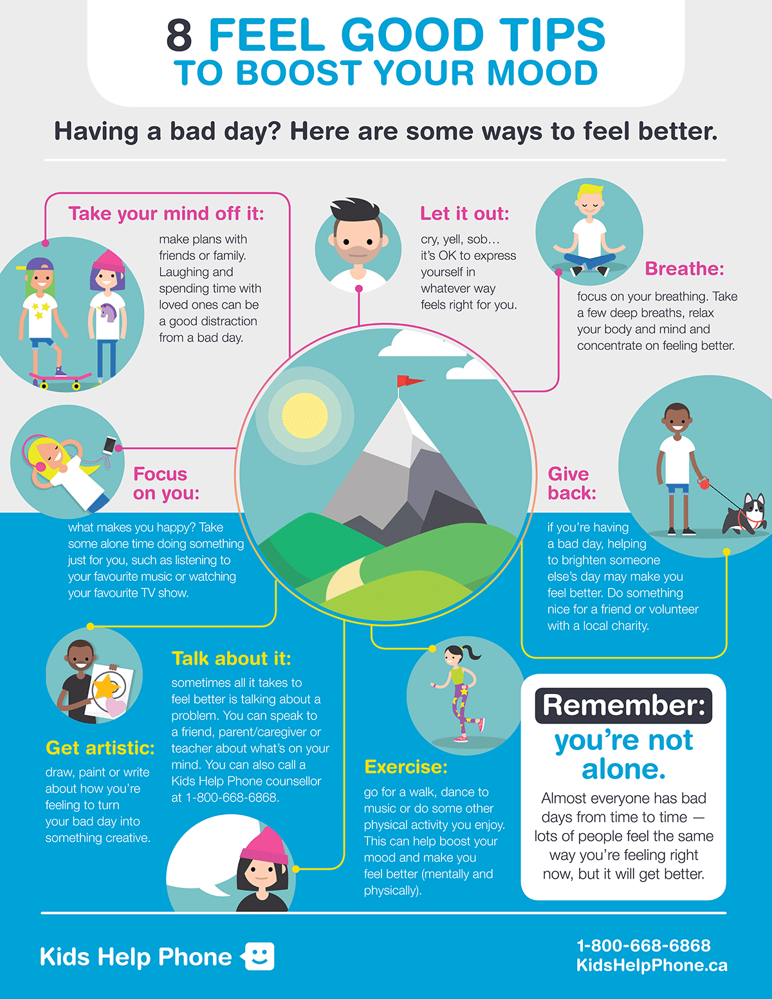(Kids help phone 2020)
Then, when they are feeling down, encourage them to do something on their mood booster list. Even if they don’t feel like doing it at first, doing something fun can help them feel better.

Create a Calm Down Kit
Fill a shoe box with items that engage your child’s senses, like a stress ball to squeeze, lotion that smells good, and a picture that she enjoys. Ask your child for their input on things that you can include that will help them calm down when they are upset, like a colouring book and crayons.
Then, when they are anxious, angry, or overwhelmed, encourage them to go get her calm down kit. This allows them to take responsibility for calming there body and brain.
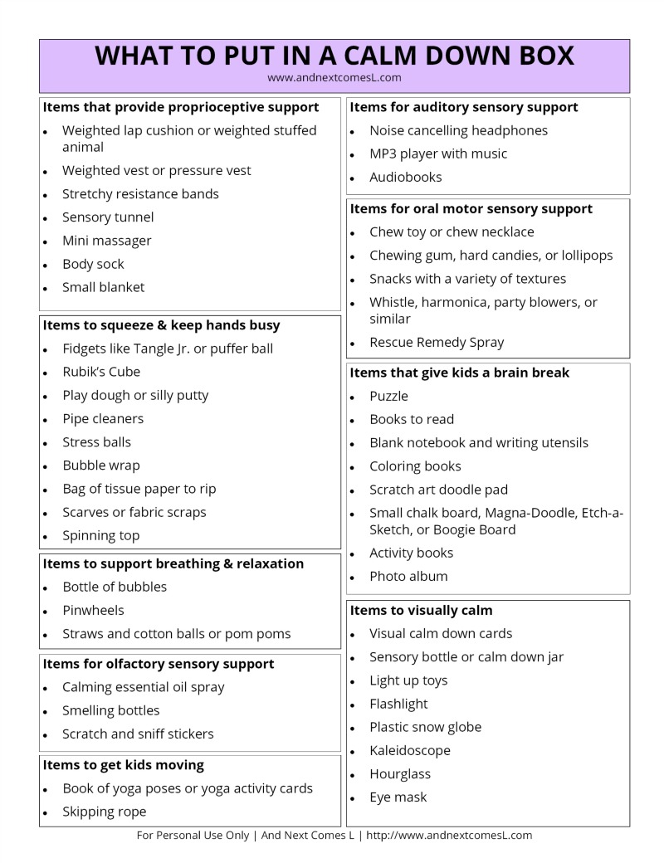(And next comes l 2020)

Grounding exercises.Grounding techniques are a powerful tool to help kids to connect to the here and now and interrupt spiralling worries. Like mindfulness it helps children calm but these techniques below can be used anywhere at any time.
54321 is an exercise where children use their senses to interrupts negative thoughts and ground them to the here and now.
54321…….
5 things you can see

4 things you can touch

3 things you can hear

2 things you can smell
1 thing you can taste
Alphabet game: Start at A and go through the alphabet on any topic of your choice. Can you get to Z ?? This is a fun activity that the whole family can engage in and it is fantastic at interrupting those negative thoughts and re directing behaviour.
Grounding Exercise
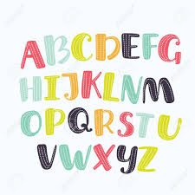
Use the Alphabet:
Go through the alphabet and choose a topic to use:

Countries-
- America
- Bahamas
- Croatia
- Denmark
- England
Football Teams-
- Arsenal
- Bradford City
- Cardiff
- Doncaster Rovers
Fruits-
- Apple
- Banana
- Cherries
- Dragon fruit

Below are a couple of additional resources which may be useful to support our young people to manage their emotions and become more resilient in the process. Teaching children about responsibility not only builds confidence, it allows children to problem solve and navigate everyday situations in a more positive manner. 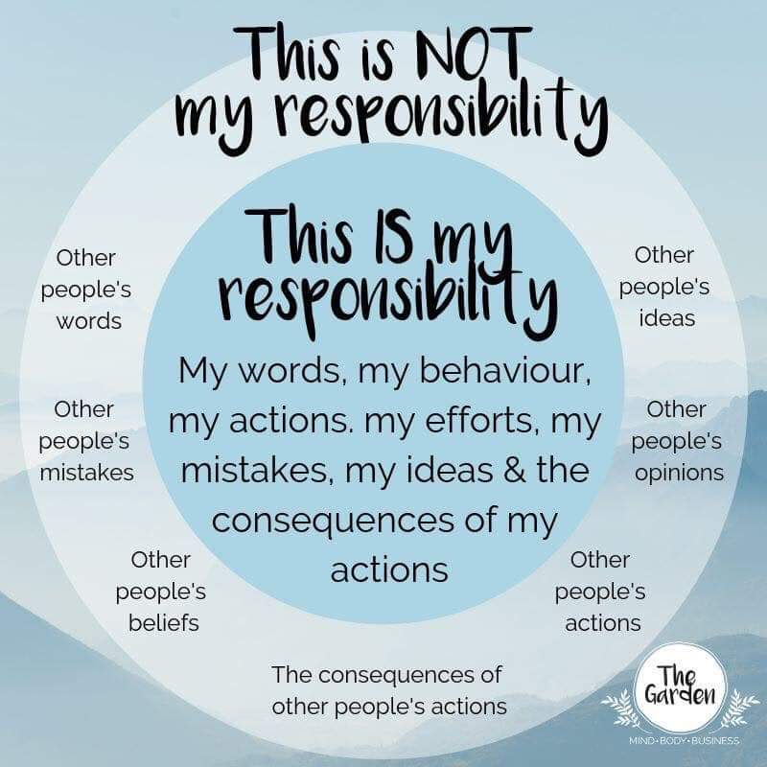
(Pinterest 2020)

The end of week check in is a lovely way to get children to reflect on there week in a positive way whilst having a safe space to share their thought and feelings.
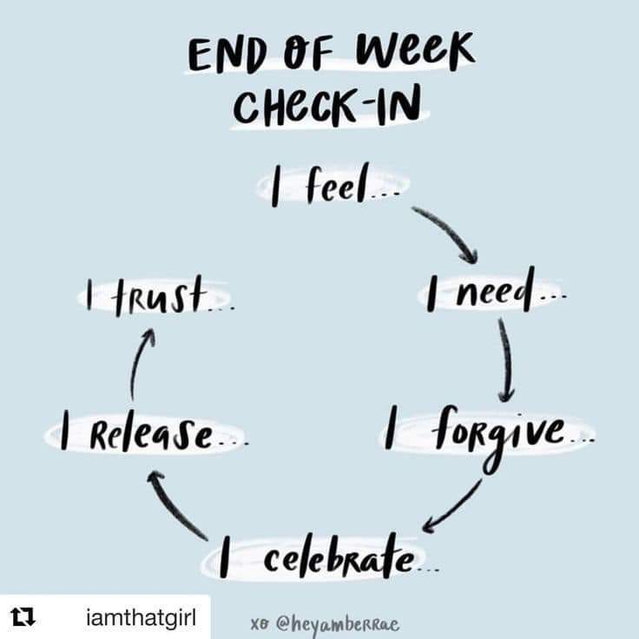
(Pinterest 2020)
Finally a nice activity to do daily on an evening whilst having that protected time with your child is to explore three good things that happened that day. Doing this as a family is a really nice way to connect and share your day. 3 Good Things diverts our minds from the negative. When we reflect on the positive, it leads to noticing even more positive. We retrain our brain to remember the good things.

